**Project Task List 1 (1%)**

**Please submit the following - one submission per team**

* Team Name – M&M
* Team Members – Moanisha Velayuthem
* Team Lead – Moanisha Velayuthem

**Project Task List 2 (2%)**

**Please submit the following - one submission per team**

* team name – M&M
* team lead – Moanisha Velayuthem
* team member – Moanisha Velayuthem
* brief project description - A muffin web store
* list of features

1. Home page – Displaying list of muffins
2. Muffin Details page – On click of muffin a page opens displaying what all the muffin contains and nutritional information
3. Store locations - Name of the locations where the store is available

**Project Task List 3 (3%)**

**Please submit the following - one submission per team**

* Project Scope: description, team members, targeted audience and objective, technical considerations (libraries),

The project is a muffin web store where we can get information about the muffins, the store locations, career opportunities available in the shop and contact information

* Deliverables

1. Displaying the home page with list of muffins
2. Displaying a navigation bar
3. Creating links on click of each item
4. Adding header and footer
5. Contact information
6. Assets: Image files

* Responsibilities and roles
* Time line (Task and schedule)

|  |  |
| --- | --- |
| Task 4 | Nov 4 – Nov 18 |
| Task 5, 6 | Nov 19 – Nov 30 |
| Task 7 | Dec 1 – Dec 7 |
| Task 8 | Dec 8 – Dec 16 |

**Project Task List 4 (3%)**

* Layout with HTML and CSS for one of your project features
* Collect content and assets for your project

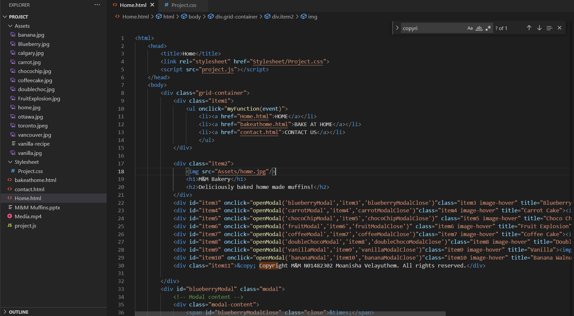

**First Feature Layout**

* Assets
* Have collected the images in this folder
* Home.html
* Contains the html code of home page
* Project.js
* Contains the JS code of home page
* Stylesheet
* Contains the css

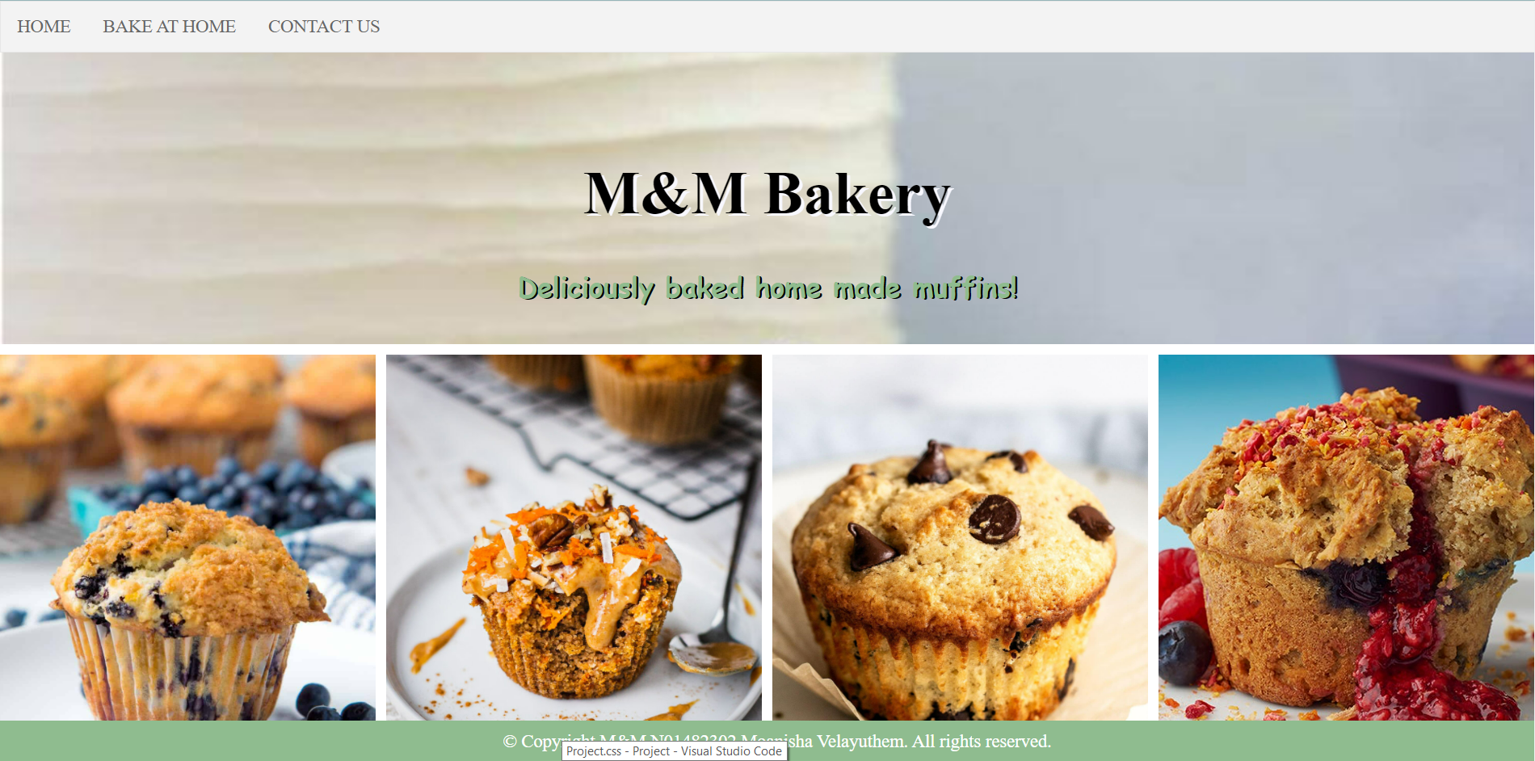

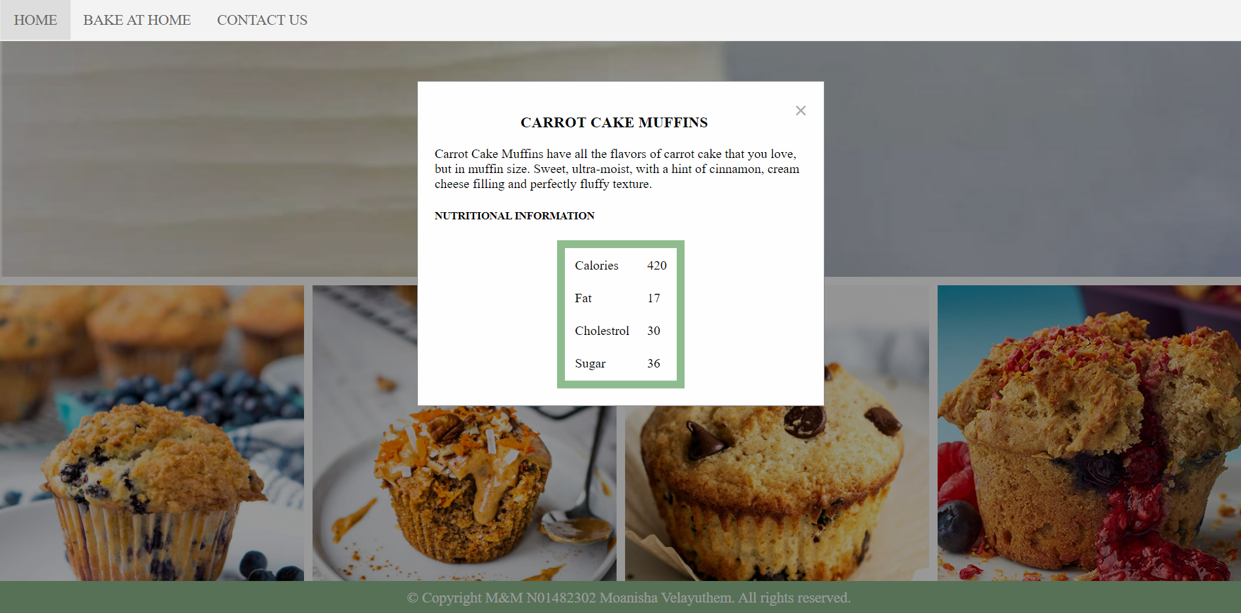

**Project Task List 5 (2%)**

* Create a consistent header, navigation, and footer area for your group project
* Create a style guide for your project
* Header and Navigation
* The project has consistent header and navigation on all three features
* Footer
* The project has consistent footer on all three features
* Stylesheet
* Contains the css

**Project Task List 6 (3%)**

* Update the Layout with HTML and CSS for one of your project features and make it responsive
* Add header, navigation, and footer area for your feature

**Header, navigation and footer area are added to the home page**

**First Feature Layout**

* Assets
* Have collected the images in this folder
* Home.html
* Contains the html code of home page
* Project.js
* Contains the JS code of bake at home page
* 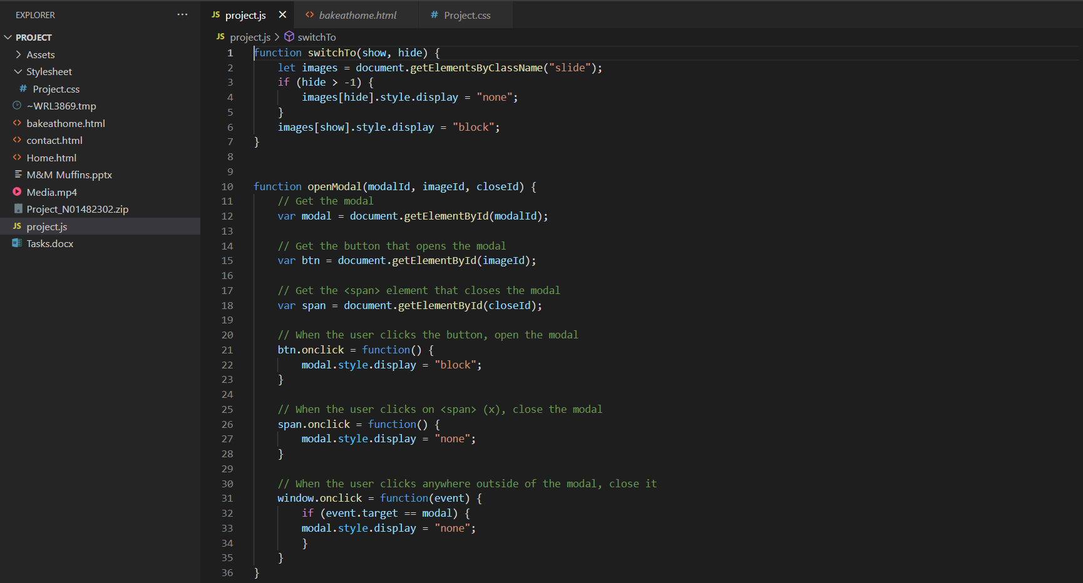
* Stylesheet
* Contains the css

**Project Task List 7 (3%)**

* Layout with HTML and CSS for your second project feature

**Second Feature Layout**

* Assets
* Have collected the images in this folder
* bakeathome.html
* Contains the html code of bake at home page
* Project.js
* Contains the JS code of bake at home page
* Stylesheet
* Contains the css

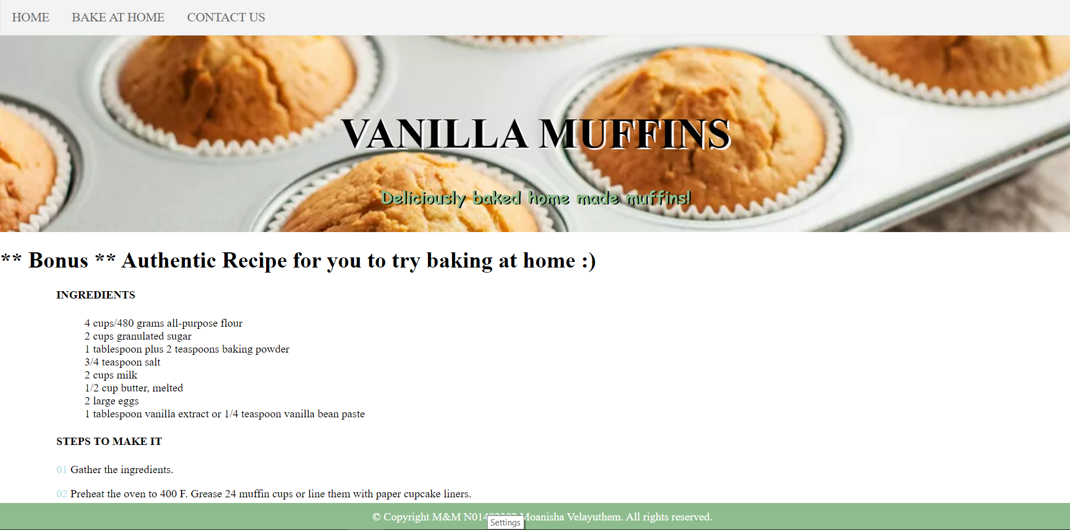

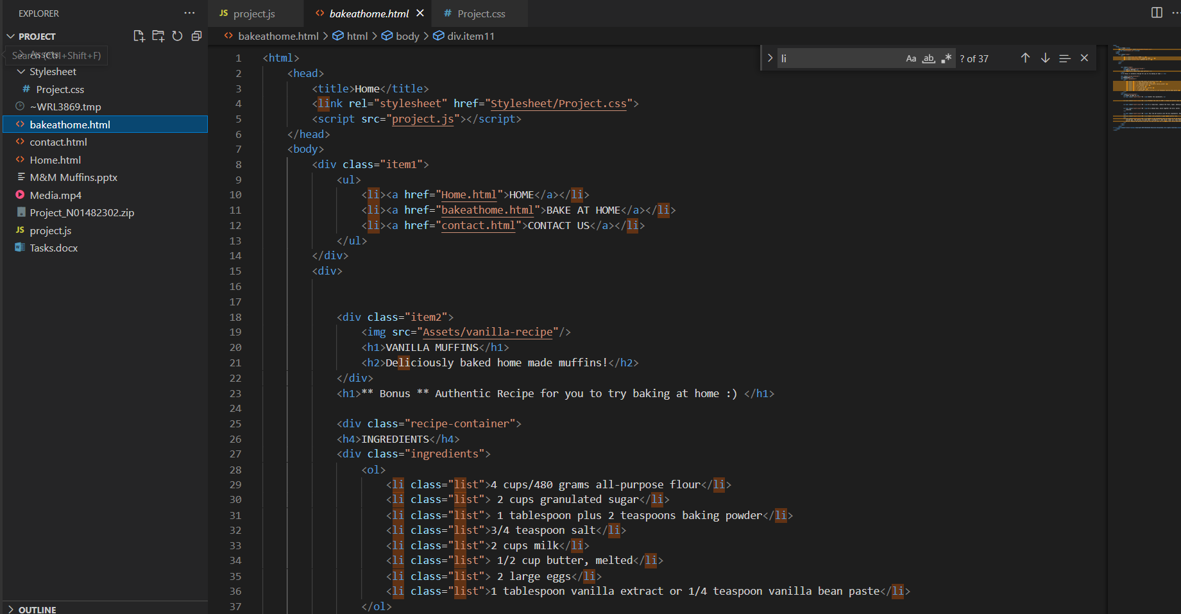

**Project Task List 8 (3%)**

* Layout with HTML and CSS for your third project feature

**Third Feature Layout**

* Assets
* Have collected the images in this folder
* contact.html
* Contains the html code of contacts page
* Project.js
* Contains the JS code of contacts page
* Stylesheet
* Contains the css
* 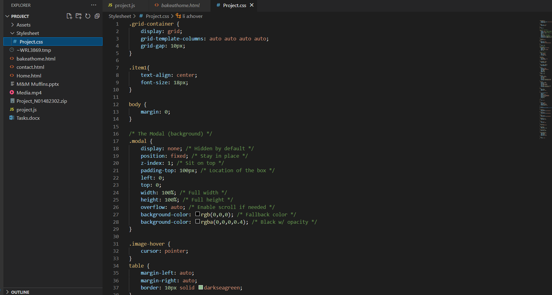

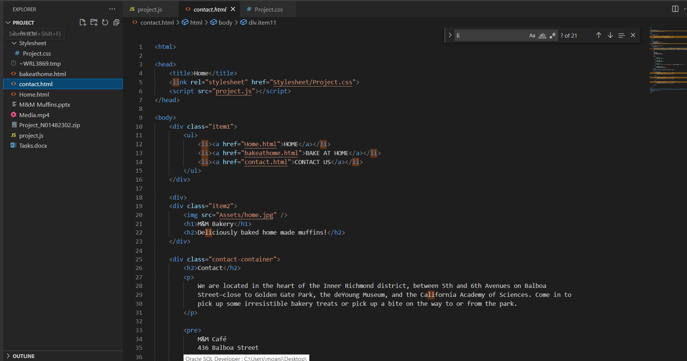

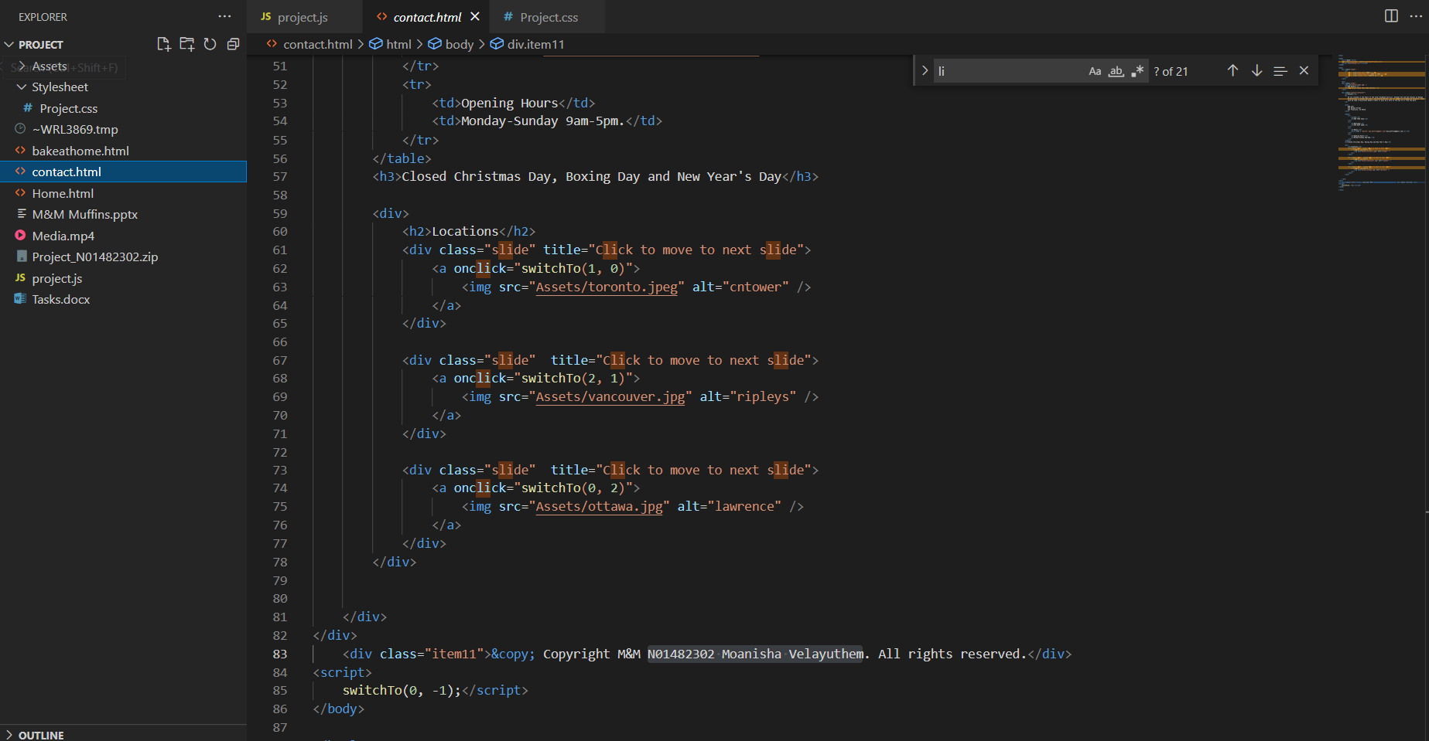

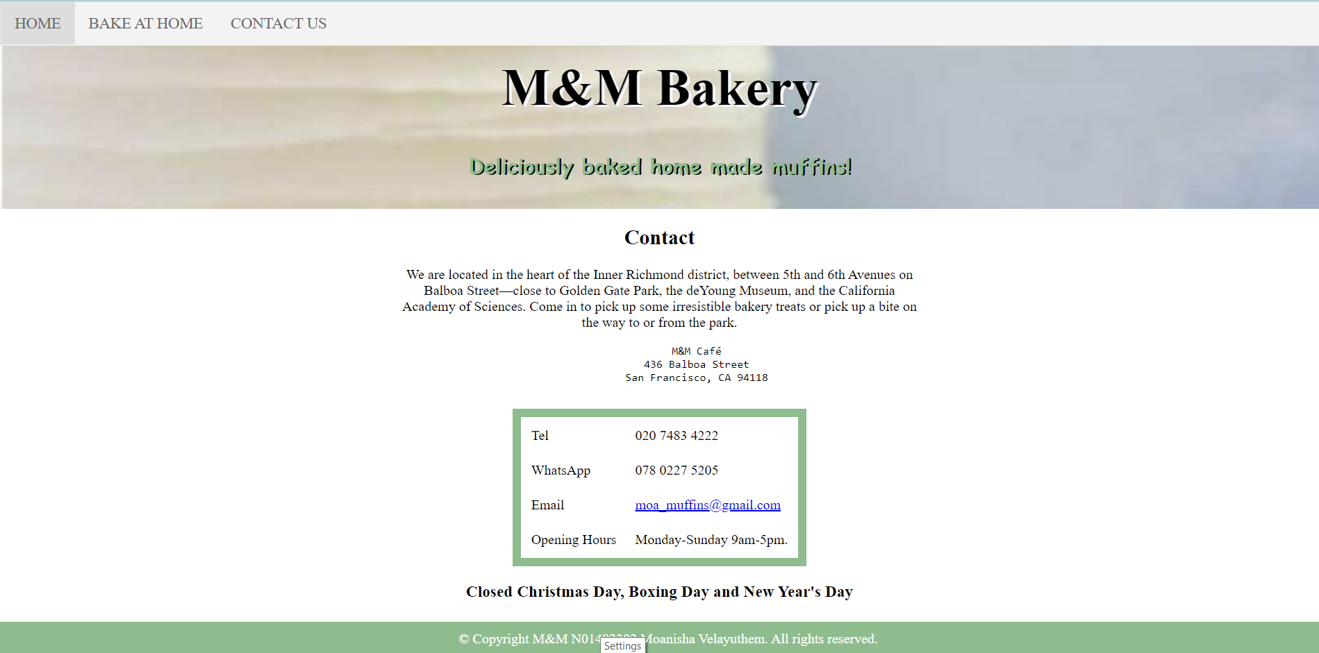

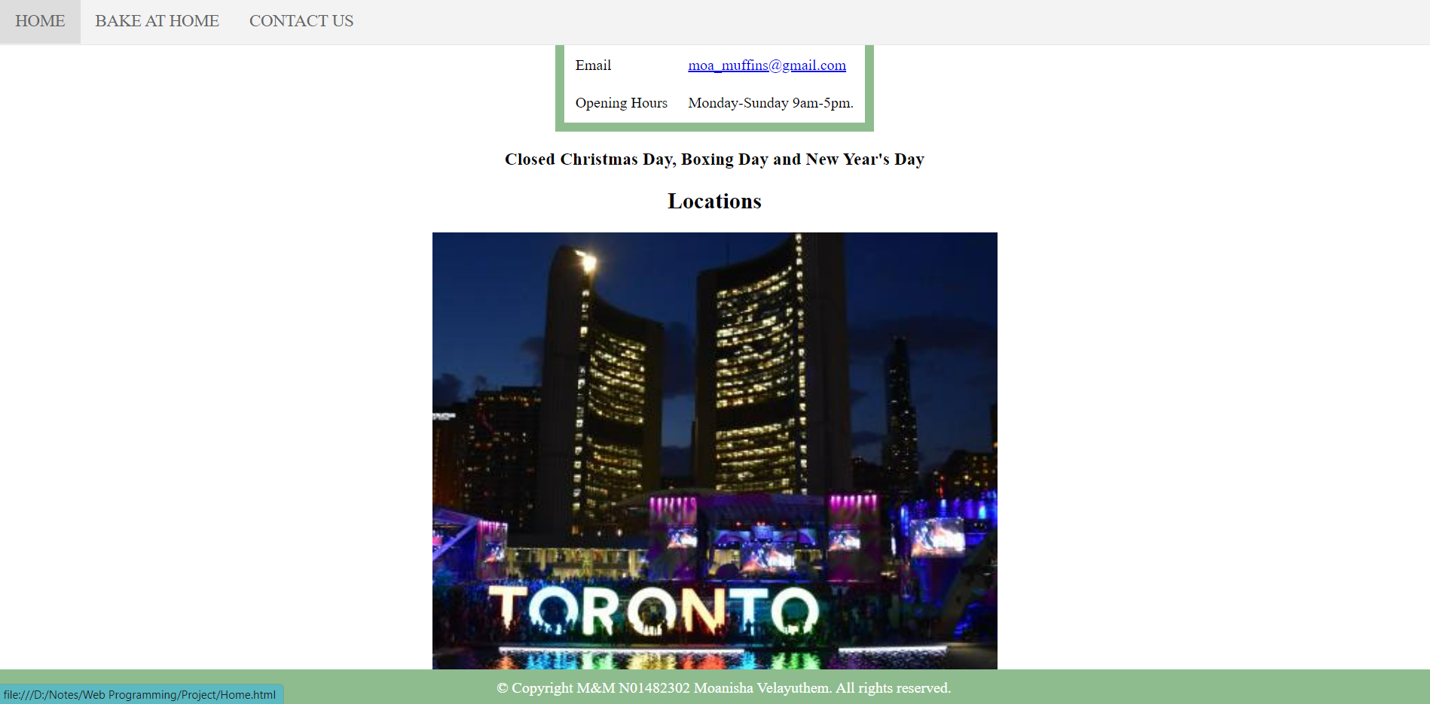

Project Phase one - **Feature one** (10%)

* Fully functional web page with HTML, CSS and JavaScript

Project Phase two - **Feature two** (10%)

* Fully functional web page with HTML, CSS and JavaScript

Project Phase three - **Feature three** (10%)

* Fully functional web page with HTML, CSS and JavaScript

**Project Phase four - Presentation and Deployment (5%)**

**Project Presentation (3%)**

* **Each group will get 20 minutes to present the final project.**
* **Everyone is required to present their project**
* **It will be a technical presentation where each team member will present one feature and explain their code, learning curve, challenges, and how did you overcome your challenges**

**Project Deployment (2%)**